|  |
| --- |
| **LAB 321 Assignment** |

**Type: Long Assignment**

**Code: J3.L.P0042**

**LOC: 200**

**Slot(s): 10**

**Title:** Manage Course

# Background

# Program Specifications

Program a web site to manage Course

**Features:**

This website contains 3 main functions

* Function 1 : Default page : ( see PIC 01)

o Display all Course contain

* + Course name
  + Course Code
  + Course Alias
  + Status

o Create Course:

* Data input
  + Course Name (required)
  + Course Code (required)
  + Course Alias (required)
  + Status(Default “Active” when create)
* “Create” button click

If Course code available in database, show alert or message “Course code is existing, please input Course Code again”

If save into database successfully, show alert or message “Create success”. If Error occur show alert or message “Create fail!”

* “Reset” button click

Clear all create form information, create form become blank

* Function 2 :View Course detail(Pic 2)
* Redirect to View Detail page when user click view detail button in Course List.
* Redirect to Course list when user click to “Back” button.
* Function 3 : Delete a course. Confirm before delete (Pic 3)

User can delete directly by click to Delete button in Course list (Pic1) or click in Delete button in Detail page (Pic2).

Show alert or message “Delete success” if delete successfully, and “Delete fail” if error occur or cannot delete.

You do not need to write interface for admin control panel, you can add data manually (use SQL SERVER Management studio).

Note: All data must be load from database, not hard code in page.

***Expectation of User interface:***

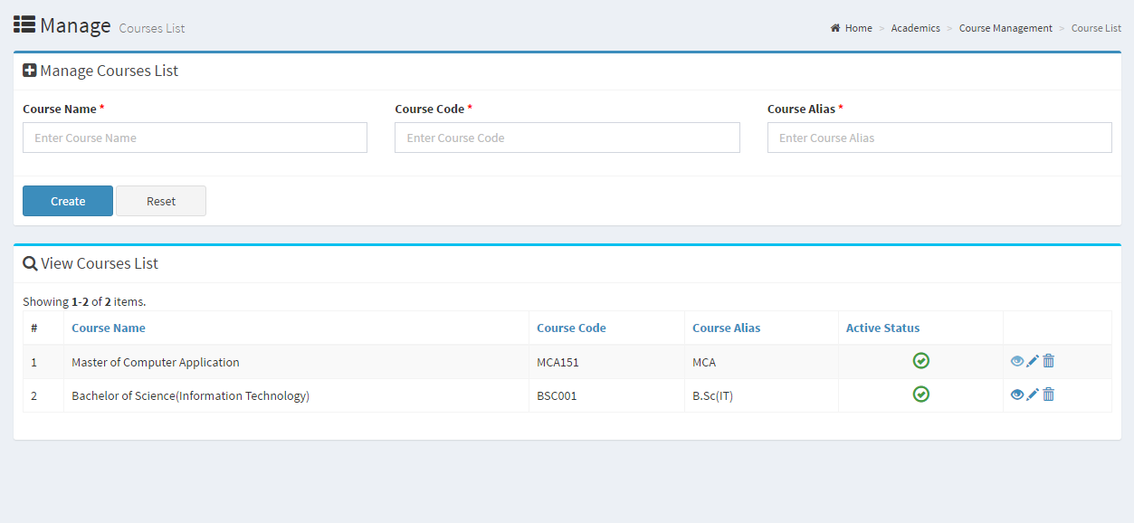

**Course list**

**Clear form button**

**Add button**

**Delete button**

**Detail button**

**Add course**

PIC 1 : Default Page

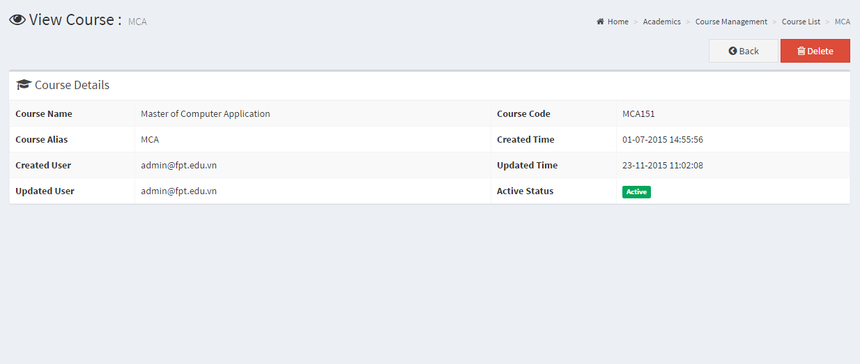

**Back to course list page**

**Delete button**

Pic 02 : Course detail

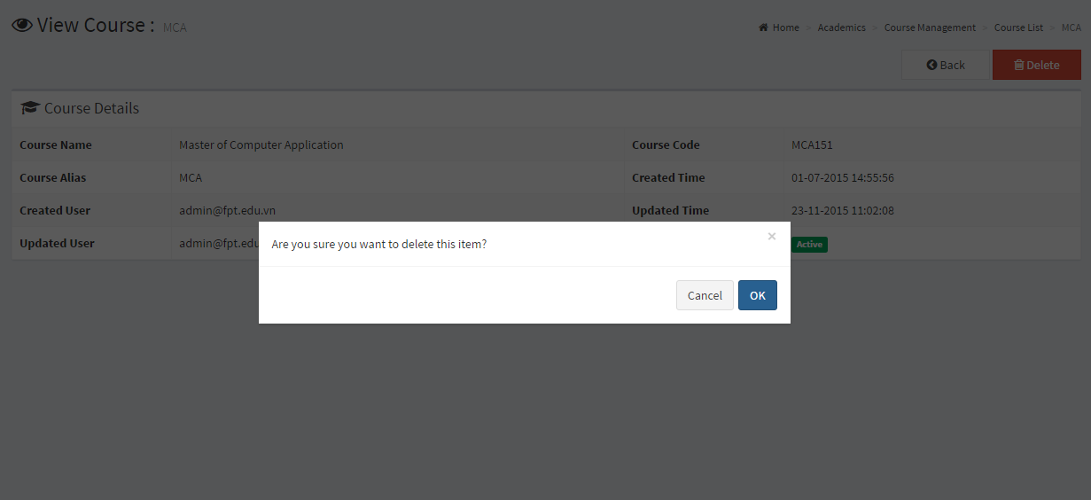

Pic 3. Delete Confirm Dialog

# Guidelines

* Step 1 : Create web layout
* Step 2 : Create prototype
* Step 3 : Design database base on created prototype
* Step 4 : Code & Test